ASSIGNMENT 11

Que 1.Write a query that uses a subquery to obtain all the orders
for the customer named cisneros.assume you do not know his customer number (cnum)
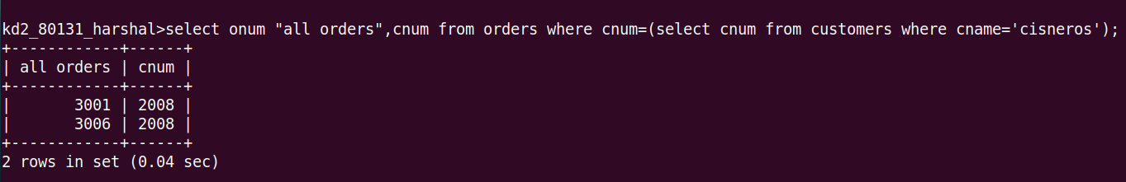
Que 2.Write a query that produces the names and rating of all
customers who have above-average orders.

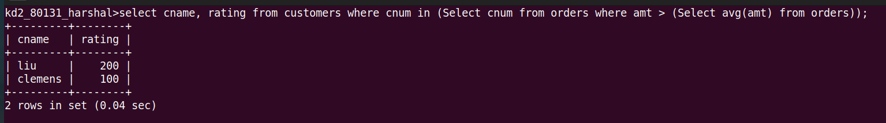
Que 3.Write a query that selects the total amount in ordes for each
salespeople for whom this total is greater than the amount of the

lsrgest order in the table.

